Project Title: QUIZ HUB

- Client-side

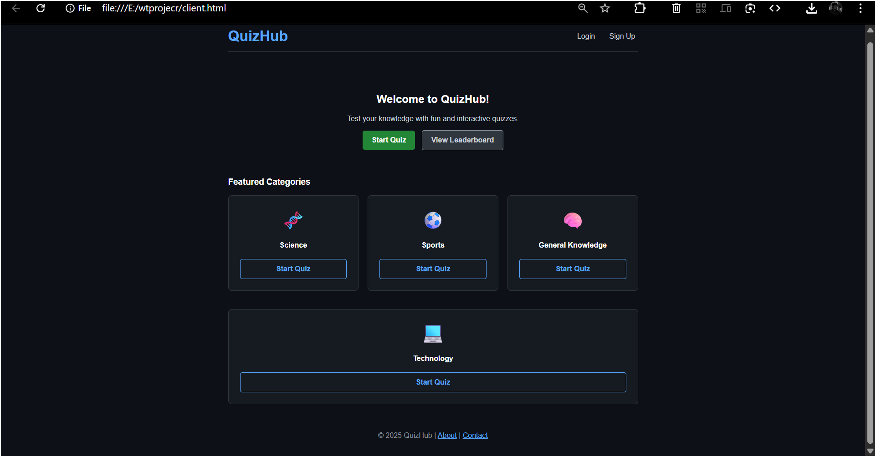

fig. 1.1 Home page screen

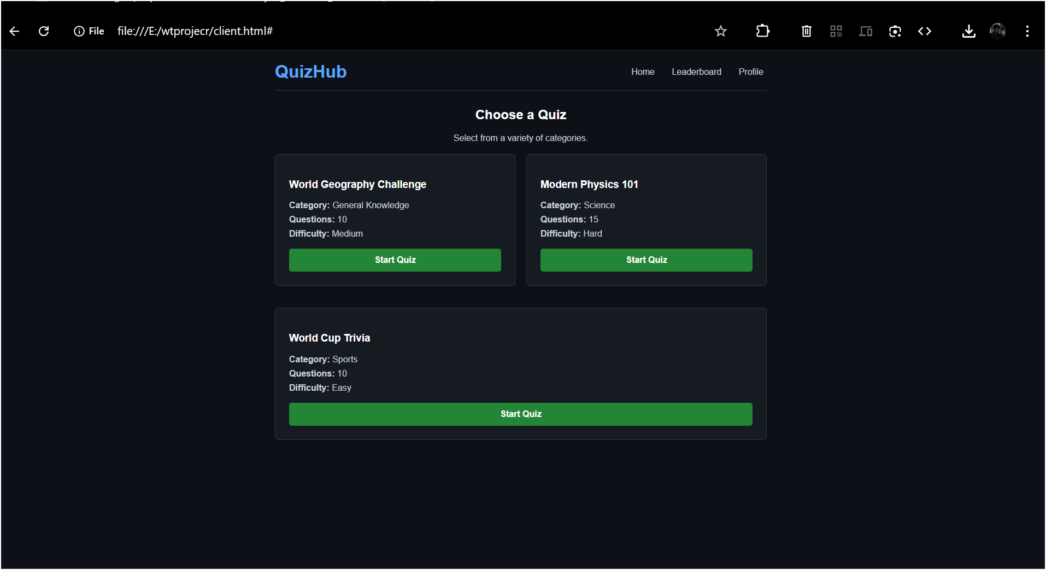

fig. 1.2 MENU PAGE

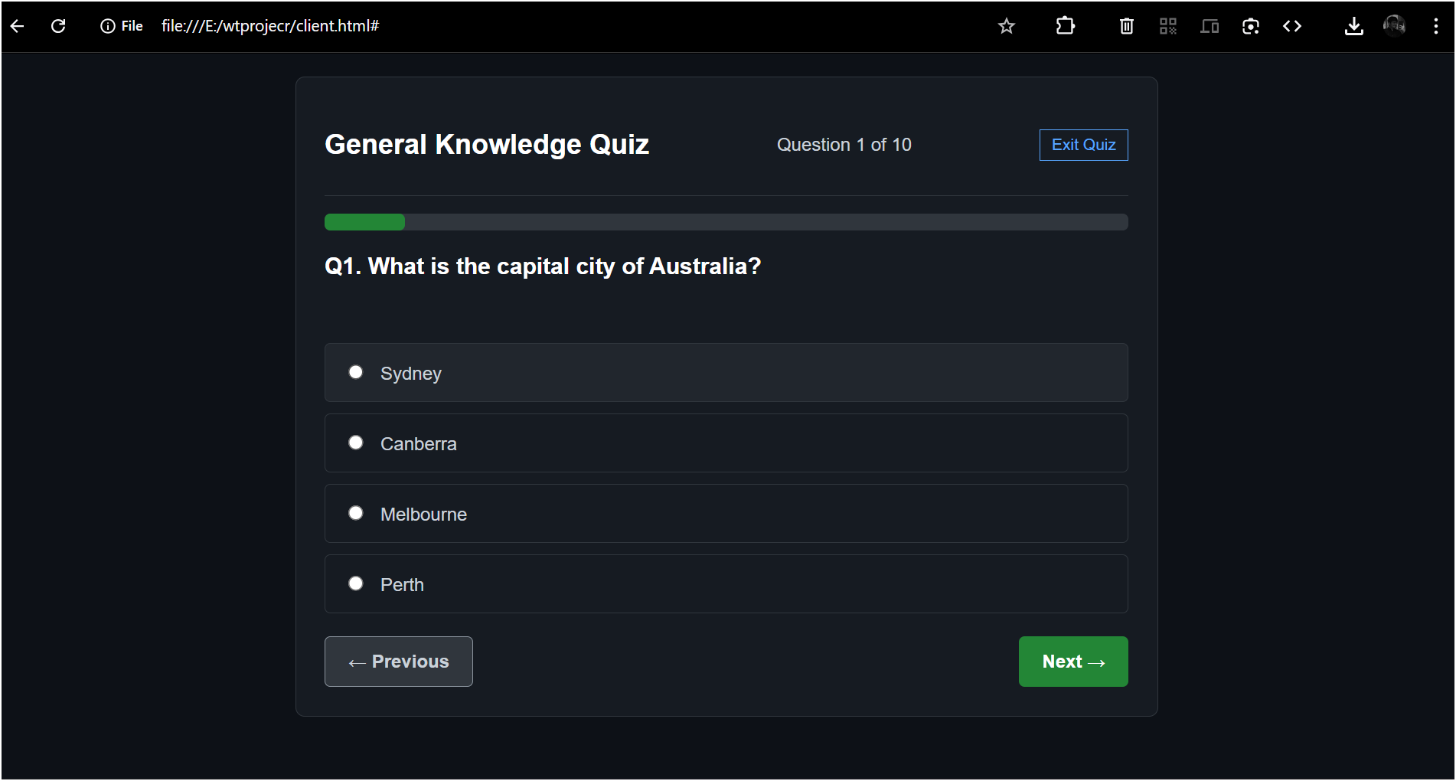

fig. 1.3 QUIZ OUESTIONS

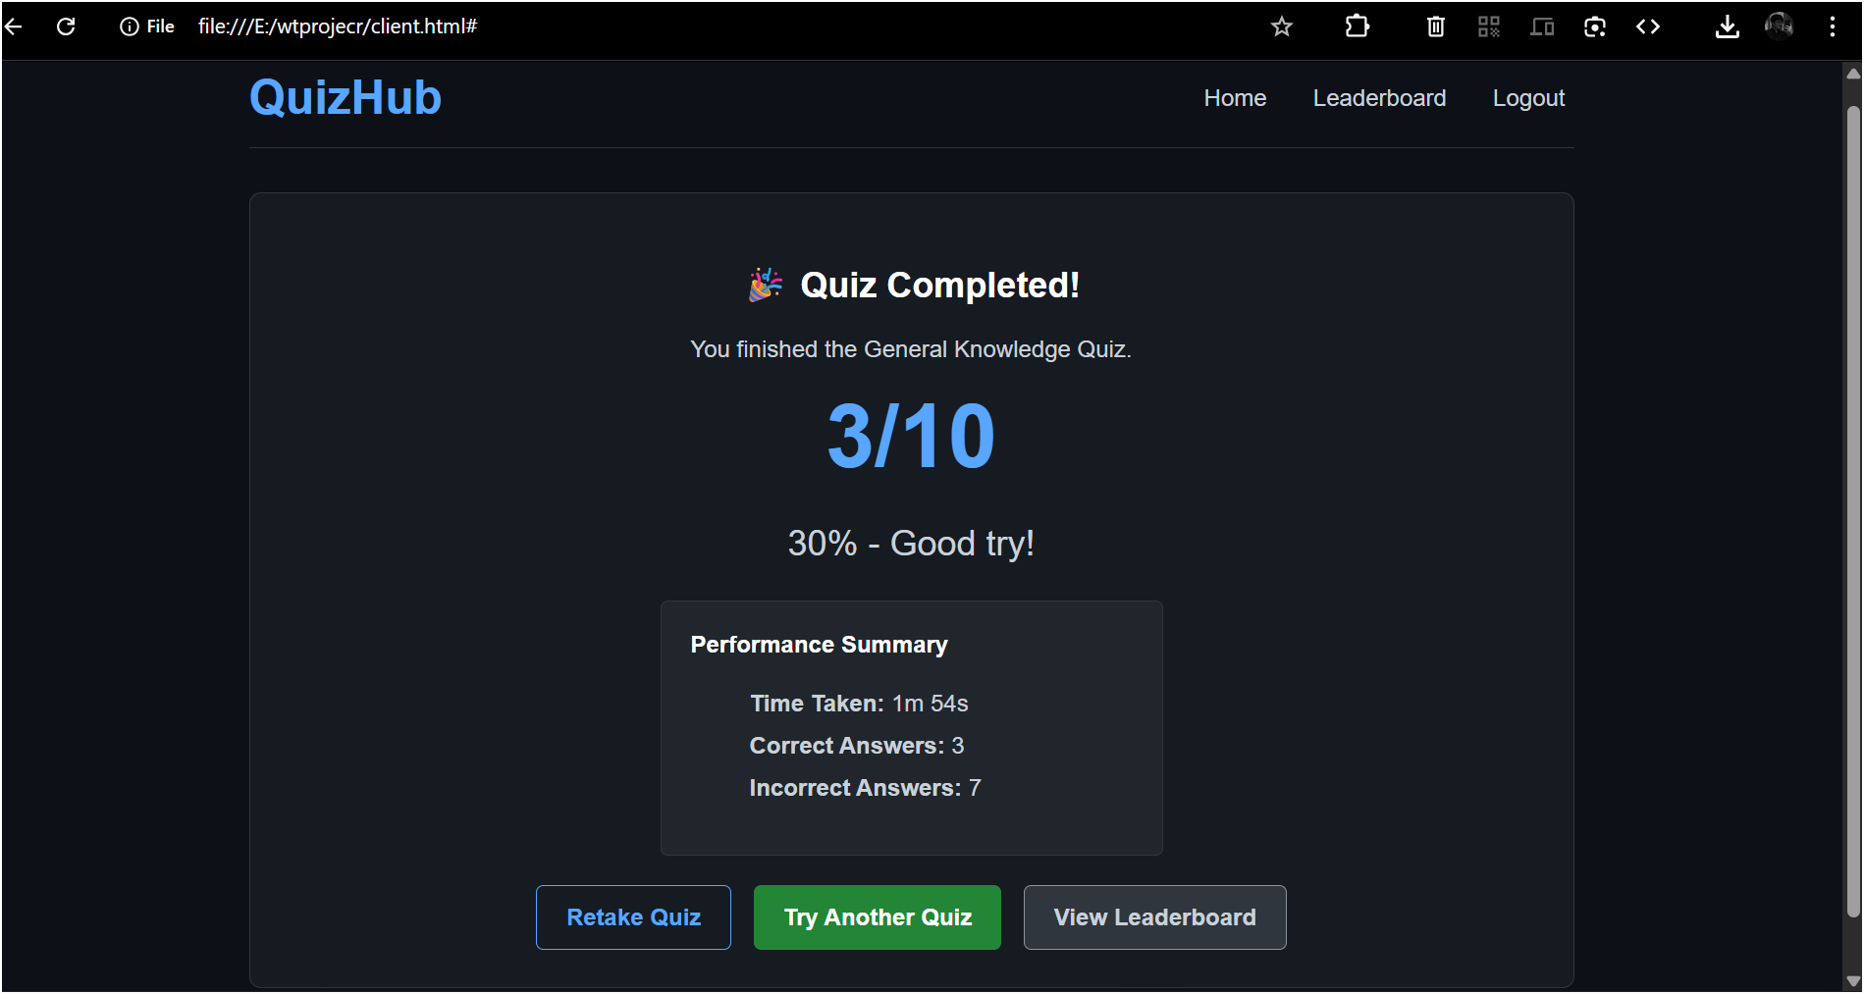

fig. 1.4 RESULT PAGE

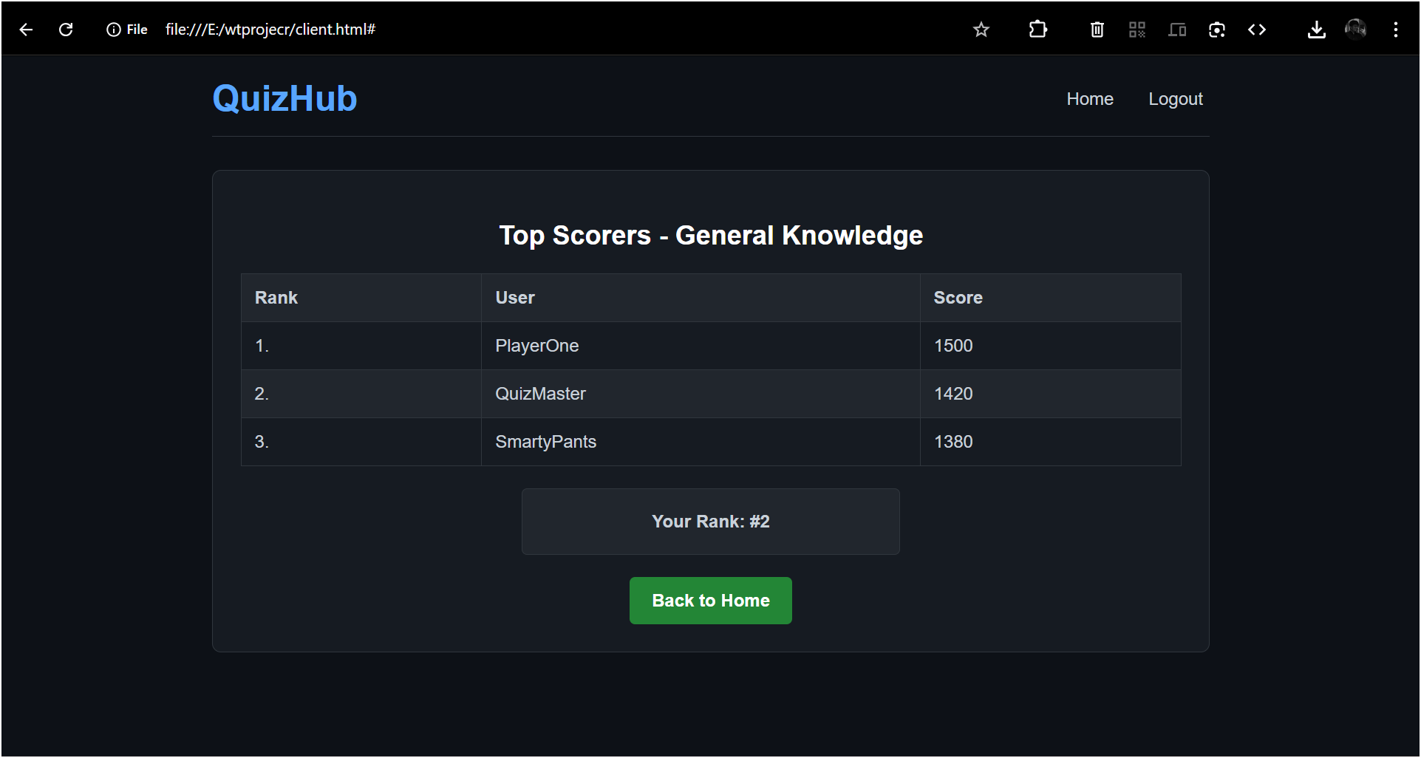

fig. 1.5 LEADERBOARD PAGE

